NEWCASTLE BUSINESS SCHOOL
The University of Newcastle, NSW, Australia

Course code: BUSA 3001
Course name: Artificial Intelligence in Business
Assignment 2 Report

Enhancing Business Decision-Making through Natural Language Processing: A Text Analytics Case Study on Apple Customer Reviews

Name | student number | Section Completed | Signed | Dated
Buu Quan Luu | C3422184 | Executive Summary, Introduction, Background of NLP feature, Proposed AI NLP Architecture, Discussion (Ethical considerations), Conclusion. | Quan | 30/05/2025

Word count: 3400 words
(excluding title page, headings, subtitles of figures, references)

Executive Summary
Today, businesses receive a huge amount of data, and it’s important to use both structured data and unstructured data to stay competitive. Text-based reviews, although complex and noisy, provide deep insights into customer experiences that numerical ratings alone cannot capture. This report demonstrates how NLP can bridge that gap by converting raw text into valuable information that supports managerial decision-making.
The report begins by outlining the importance of NLP in transforming human language into machine-readable formats. Key techniques such as text preprocessing, sentiment analysis, vectorization, and topic modeling using LDA are introduced. These methods allow businesses to identify patterns, common sentiments, and recurring themes in customer reviews.
The case study on Apple’s product reviews shows how a structured NLP pipeline, built using Python and libraries such as NLTK, Gensim, and Scikit-learn, can be applied to real-world data. The dataset of over 1,000 reviews was cleaned, preprocessed, and analysed to classify sentiment and uncover 10 core topics that reflect both customer satisfaction and areas for improvement. Visual tools such as word clouds, frequency plots, and n-gram charts were used to make findings accessible and meaningful for business stakeholders.
The report also addresses ethical considerations related to data privacy, fairness, bias, and the responsible use of AI-generated insights. It emphasizes the need for transparency and compliance with data protection regulations such as the GDPR.
Overall, NLP offers a scalable, efficient, and ethical approach to understanding unstructured customer feedback. Its application in this project reveals how organisations can use textual analytics to inform product design, improve customer experience, and support data-driven strategy development.

Table of Contents
Executive Summary 2
1. Introduction 5
2. Background of NLP Features 5
2.1. Case study: Apple’s Customer Review Analysis 5
2.2. Key NLP Capabilities for this context 6
2.3. Advantages of NLP for Decision Makers 6
3. Proposed NLP AI Solution architecture 7
3.1. Importing necessary libraries 7
3.2. Loading dataset 7
3.3. Dataset preparation 8
3.4. Exploratory Data Analysis (EDA) 9
3.5. Text data preprocessing 9
3.6. Data visualization 10
3.7. LDA for topic modeling 10
4. Data Presentation 11
5. Discussion and Conclusion 14
5.1. Ethical Considerations 14
5.2. Conclusion 14
6. References 15

Table of Figures

Figure 1: Importing libraries (author’s work) 7
Figure 2: Customer reviews on iPhone dataset (author’s work) 7
Figure 3: Dataset Description (author’s work) 8
Figure 4: Dataset Cleaning and Sentiment Labeling (author’s work) 8
Figure 5: Rating distribution and Sentiment Distribution (author’s work) 9
Figure 6: Number of Review by Sentiment Over time (author’s work) 9
Figure 7: Preprocessing steps in textual data (author’s work) 10
Figure 8: LDA Topic Modeling (author’s work) 11
Figure 9: Results of Topic Modeling (author’s work) 11
Figure 10: Overall Word Cloud and its frequency plot (author’s work) 11
Figure 11: Positive reviews and Negative reviews Word Cloud (author’s work) 12
Figure 12: Frequency plot of positive and negative reviews (author’s work) 12
Figure 13: Frequency plot of Bigrams (author’s work) 13
Figure 14: Frequency plot of Trigrams (author’s work) 13
Figure 15: Top 10 topics modeling after LDA (author’s work) 13

Introduction
Businesses are currently overwhelmed with textual data from customers, employees, and digital interactions in this data-driven economy. The unstructured data is not widely utilised because of its complexity, noise, and significant volume data sources; for example, in the textual data, which is human language, there are language barriers and ambiguity (Eskandar, 2023), while the structured data has contributed to the organisation’s decision-making through the application of the business intelligence technology. However, this unstructured data frequently contains meaningful information, which may help the businesses to identify the market trends, operational difficulties such as weaknesses and threats, and consumer feedback. The rich insights qualitative, especially textual data, can provide, its adoption has been limited (Sinkovics, 2005)
More specifically, the challenges of text analysis focus on turning raw and inconsistent data into valuable information that decision-makers can use. Therefore, an automated text analytics solution using NLP needs to be applied to effectively implement this data, enhancing information-driven capabilities for managerial decision support and limiting error from manual analysis by humans. By combining linguistic, statistical, and AI techniques, NLP can interpret or generate human-like text. It is commonly used in everyday technologies like smartphones and software (Fanni, 2023).
This report examines the application of NLP to enhance text analysis for better decision-making. Focusing on Apple product reviews, it outlines key NLP features, presents the architecture of a Python-based solution, and explains how preprocessing, sentiment analysis, and topic modeling provide actionable insights to support timely and strategic business improvements.

Background of NLP Features
In the advancement of data-driven transformation, Organisations face with many different data types with huge quantities, including structured, semi-structured and unstructured data. While structured data has been used popularly for driven business strategies because of its organised formats, such as numeric data, and ease of use, unstructured data, especially in text data, was ignored despite its potential to generate applicable meanings that the numerical data cannot present. For example, online product reviews often reveal how customers truly feel about specific product features, service experiences, and brand values. The sources can be take from customer feedback, social media, internal communications, and digital interactions (Feldman & Sanger,2007).
It is apparent that the organisations encounter some challenges leading to some obstacles when performing text analysis, for instance, noise, complexity, inconsistency and context dependency. However, it can help cluster the different aspects of customer satisfaction and dissatisfaction, market perception in the structured way, rather than the traditional approach tools. Therefore, the integration of NLP technique into the text analysis, which is the progress of transforming human languages into the computer’s languages with an appropriate computational solutions, such as Latent Dirichlet Allocation (LDA), Latent Semantic Analysis (LSA), and Long-Short Term Memory (LSTM), etc, to gain the desired requirements of the organisations bridging the gap between the unprocessed data and actionable strategies (Cambria & White, 2014).

Case study: Apple’s Customer Review Analysis
Apple Inc. is a leader in technology and innovation and has a wide range of technological ecosystems. In the context of this project, NLP has implemented analysis into the large dataset of online reviews of customer experiences with Apple’s Products, specifically about the satisfaction rate of an iPhone in different aspects from its appearance to operational efficiencies. This growing database of information customers provide provides a wide variety of insights that can guide product development, marketing strategies, and customer service improvements. Its goal is to discover hidden sentiments, frequent problems, and recommended features, meaning to determine the hidden themes behind these reviews through the LDA technique, allowing Apple to enhance products in response to real consumers’ demands.

Key NLP Capabilities for this context
Natural Language Processing, a branch of Artificial Intelligence, encompasses a wide range of complex tasks involving human language, such as machine translation, topic identification, and question answering. According to Lauriola (2022a), NLP is divided into two major areas: fundamental research and applied research. In the context of analysing customer reviews for Apple products, the focus lies on applied NLP, particularly in automatically extracting meaningful insights from Amazon reviews. For this purpose, essential tools like the Natural Language Toolkit (NLTK) and Gensim are commonly employed.
- Text preprocessing: This includes several tasks such as tokenization (splitting text into individual words), removal of stop words (commonly used words that add little semantic value), lemmatization (reducing words to their base forms), and noise removal (such as punctuation and special characters). Therefore, the text preprocessing is considered as an important step that significantly improve on feature selection and extraction accuracy (Uysal, 2014)
- Sentiment Labeling: this step involves assigning a sentiment category to each review based on the customer's ratings. In this project, a rule-based approach is implemented to classify into 2 types of sentiment categories, including positive and negative. This binary classification helps in quickly determining the overall sentiment trends in the dataset, allowing broader analytical tasks by enabling quick aggregation and comparison of customer opinions (Vinodhini & Chandrasekaran, 2012).
- Text Vectorization: To help the computers understand text, it must be converted into numerical format through Vectorization. Techniques like CountVectorizer are applied to transform textual information into feature vectors that represent the frequency of terms within the corpus. These vectorized datasets are then used in machine learning models for tasks such as text classification, allowing the automatic grouping of reviews into relevant categories, such as hardware issues, user experience, or customer service quality.
- Topic Modeling using LDA: Latent Dirichlet Allocation represents topics by word probabilities. Therefore, it is the most effective methods for topic modelling because it identifies hidden structures in large text corpora without supervision (Chauhan & Shah, 2022). It means each dataset is a mixture of topics and each topic is a distribution over words, making it effective for organizing, summarizing, and understanding unstructured text.

Advantages of NLP for Decision Makers
NLP offers several key advantages for organisational decision-making. It enables rapid analysis of large volumes of customer feedback, allowing managers to act quickly on emerging issues. By automating text analysis, NLP reduces human bias and ensures more objective insights. It also improves resource efficiency by extracting value from existing data, eliminating the need for new surveys. NLP provides deeper understanding by uncovering the emotional and behavioural drivers behind customer actions, offering context that structured data often lacks. Additionally, its integration with dashboards enhances data visualisation, making insights easier to interpret. As digital interactions grow, NLP becomes essential for transforming unstructured text into actionable business strategies.

Proposed NLP AI Solution architecture

Importing necessary libraries
Prior to analysing the text dataset, it is important to install the relevant packages and libraries to ensure that the completed text is well-prepared for thorough NLP analysis, specifically using LDA. The project incorporates several Python libraries to support efficient data handling and NLP tasks. Pandas and NumPy manage tabular data, while re handles text cleaning using regular expressions, and Counter calculates word frequencies. tqdm adds progress bars for long-running processes.
For NLP, NLTK supports key preprocessing steps such as tokenization, stop word removal, and lemmatization. It also enables generation of bigrams and trigrams, helping reveal deeper patterns in customer feedback. NLTK is a robust platform offering tools for parsing, classification, and semantic reasoning (Lauriola et al., 2022b).
Topic modeling is conducted using Gensim and Scikit-learn. Gensim’s LdaModel and Dictionary are optimized for large-scale, unsupervised topic modeling (Lauriola et al., 2022c), while Scikit-learn’s CountVectorizer and LDA offer a streamlined alternative for uncovering hidden themes. For visualization, matplotlib, seaborn, and wordcloud present distributions and key terms.
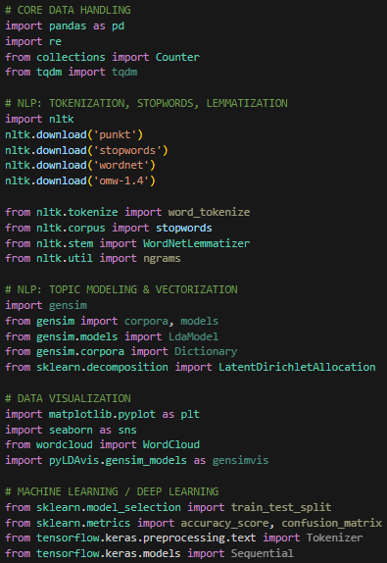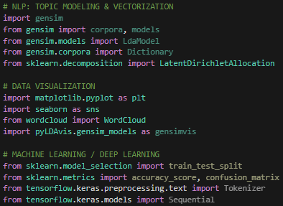
  - Figure 1: Importing libraries (author’s work)

Loading dataset
First, it is needed to import pandas to load the dataset, which is widely used for CSV files to handle the table format. After loading the dataset, it includes 1165 rows with 6 columns in total, consisting of Product ID, Country, Date, isVerified, Ratings (from 1 to 5), and Reviews.
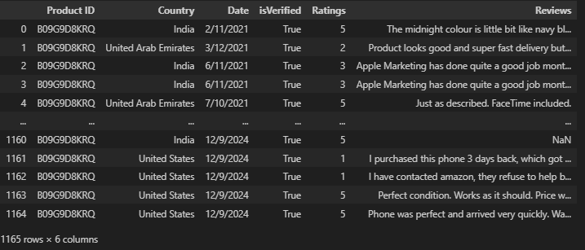
  - Figure 2: Customer reviews on iPhone dataset (author’s work)

Dataset preparation
After that, data exploration needs to be carried out to verify the shape of the dataset, check for data types in each column, check for missing values and duplicated values and show the descriptive statistics of the dataset. From the figure below, there are six columns. Four of these are types of object, and the data type of the two remaining columns, which are ‘isVerified’ and ‘Ratings’, is categorized as Boolean and integer, respectively. Furthermore, there are 235 duplicated values and 37 missing values in the ‘Reviews’ column. In terms of the descriptive statistics, most of columns are the textual form, therefore its results indicate the NaN (Not a Number), excepting for the ‘Ratings’ column.
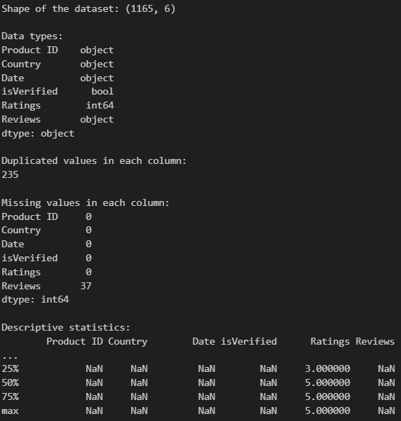
  - Figure 3: Dataset Description (author’s work)
As there are many missing and duplicated values that were recorded from the previous step, the rows having these values need to be removed, therefore the dataset has 903 rows that are unique values and are ready for analysis. Then the ‘Date’ column is converted into datetime datatypes to be prepared for visualizations in the further steps. Besides that, in NLP analysis, not all the columns contribute to the analysis process, therefore some unnecessary columns are dropped to clarify for the analyst. After that, based on the ratings that were evaluated from consumers, it is divided into two groups, positive and negative sentiment results. If the ratings are higher or equal to 4, it is positive comments or if the ratings are lower or equal to 3, it is negative comments, then these sentiment results will be updated to the new added column called ‘Sentiment Results’.
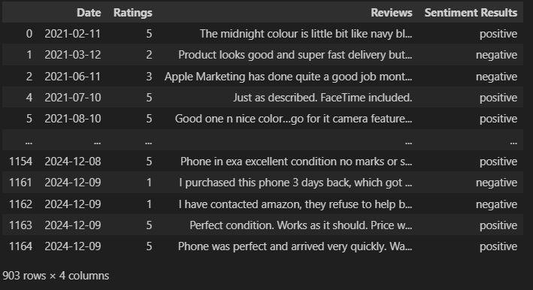
  - Figure 4: Dataset Cleaning and Sentiment Labeling (author’s work)

Exploratory Data Analysis (EDA)
The data exploration is conducted to explore more information in that dataset after cleaning, in this step, the ratings distribution is illustrated through bar chart, which has ratings (x) and count (y), it can be seen that the numbers rating of 5 accounts for large portion of the dataset, with more than 400 in total. Therefore, when it is separated into sentiment results, bar graph that have sentiment results (x) and count (y), the positive reviews are approximately 580, which is higher by around 230 than that of negative.
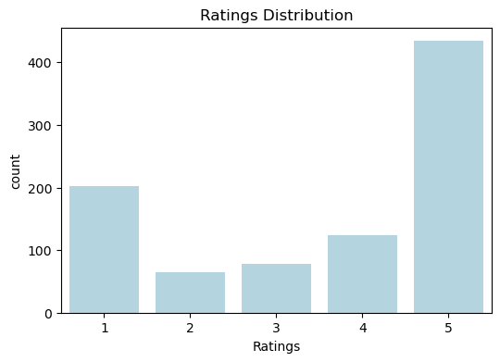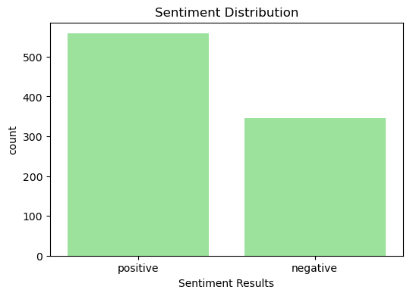
  - Figure 5: Rating distribution and Sentiment Distribution (author’s work)
The line graph below shows the number of reviews by sentiment, which was distributed during the 4 years from November 2021 to August 2024. The number of positive reviews over time is higher than that of negative in most of the recorded time, also due to the disruption of the negative reviews in some periods from July 2021 to Jan 2022, which proves for the displayed distribution in the first two graphs; however, the number of negative results was crossed over the positive one in May, August 2022 and in August 2023.
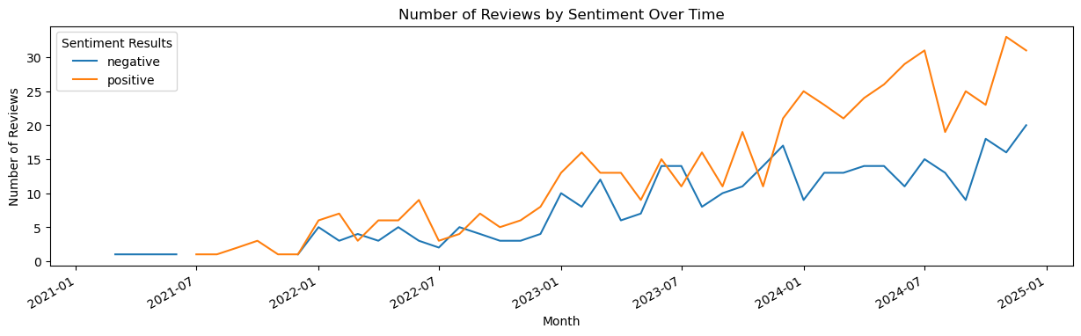
  - Figure 6: Number of Review by Sentiment Over time (author’s work)

Text data preprocessing
After finishing some dataset cleaning and data exploration, the next essential step to perform is textual data preprocessing. Firstly, the ‘Reviews’ column which is the primary information used for the analysis, is utilized Lemmatizer to reduce words to their base form and stop words to reduce noise by removing common words in English that is not affect to the analysis result, such as ‘the’, ‘a’, and ‘an’. As it is an in reviews’ dataset of Apple’s products, it contains some common words in this specific area that need to be removed, such as ‘phone, apple, product, iPhone, amazon, android’, etc.
When the reviews write their comments, they usually add emojis to express their feelings more accurately with the product at those moments, however, it is a complex problem for computers to understand what it means because it is a type of human language. Therefore, it is needed to create a function to remove the emojis. Then, the functions of cleaning and tokenization are also created to put all the characters into lowercase and remove punctuation, extra spaces, numbers, single characters, followed by tokenization function which is to split all the single words and return tokens back to a clean string for each review. Next, the new columns, namely ‘Cleaned_review’ and ‘tokens’, are created to store the cleaned textual data and the tokens.
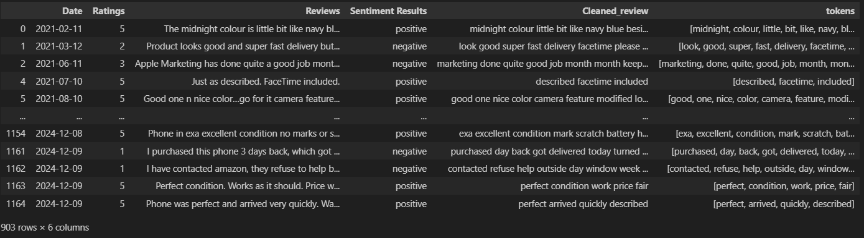
  - Figure 7: Preprocessing steps in textual data (author’s work)

Data visualization
In textual analysis, data visualization plays a crucial role in uncovering patterns, themes, and key insights from large volumes of unstructured text. Tools such as word clouds, frequency plots, and n-gram visualizations are commonly used to explore customer reviews, as in the given dataset of Apple product reviews, making the data more interpretable but also help in validating the effectiveness of preprocessing steps such as stop words removal, lemmatization, and tokenization.

One foundational technique is the word cloud, which conveys term frequency through font size and spatial prominence. This method offers immediate visual cues about dominant themes, providing an intuitive snapshot of customer priorities. These are particularly powerful in early-stage exploration the common words and for communicating findings to non-technical stakeholders to understand the insights. However, there is a limitation when assessing text relevance to specific information, so they often used in a static way with little to no interactivity (Heimerl et al., 2014).

A frequency plot, such as the bar chart created in the provided code, ranks words based on how often they appear. Unlike word clouds, frequency plots provide a more precise and quantitative view as it can illustrate the exact numbers of time that words appear. In the context of the Apple reviews dataset, such a chart helps in pinpointing the most discussed features. This information can guide further analysis or decision-making, such as prioritizing which product features to investigate for potential improvements.
Unlike the word clouds which display the single words without much interactivity, N-gram visualizations, especially bigrams and trigrams, capture short phrases that are common and reflect user sentiment and feature interdependencies. These multi-word expressions enable companies to detect nuanced perceptions, uncover correlated complaints or praises, and align product strategies accordingly (Tan, 2002). Furthermore, when integrated with frequency plots, these visualizations become even more powerful, as they display the exact occurrence counts of each phrase.

LDA for topic modeling
To perform the LDA, the process commences with the random selection of 900 cleaned reviews, ensuring efficient computation while maintaining topic diversity, all while employing a fixed random seed for reproducibility. This text is then converted into a numerical format using CountVectorizer. During this transformation, it filters out both common and rare words, as well as removes English stop words. This structured representation of the text facilitates the application of the LDA algorithm (Figure 8).
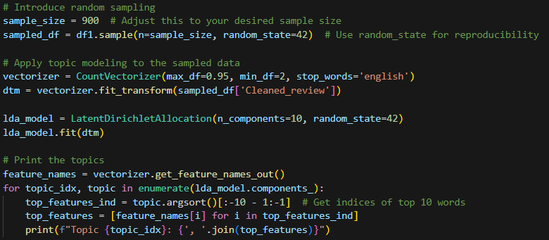
  - Figure 8: LDA Topic Modeling (author’s work)
The LDA model is configured to identify 10 distinct topics and is trained on this matrix to uncover clusters of words that frequently occur. Each topic is characterized by its top keywords, which are extracted and analysed to reveal significant themes such as product quality, battery performance, customer service, and value for money. This step offers valuable insights into customer feedback, empowering data-driven decisions in product development and customer experience strategies (Figure 9).
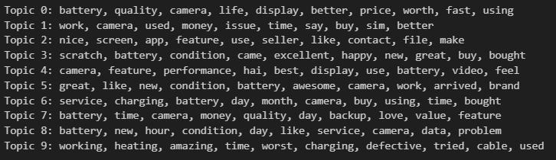
  - Figure 9: Results of Topic Modeling (author’s work)

Data Presentation
From Figure 10, there are several aspects of the iPhone that stand out prominently and mention frequently through clients’ reviews, such as ‘good’, ‘camera’, ‘batter’, ‘like’, ‘new’, etc., in the Word Cloud. This visualization indicates that customer attention is concentrated around these features, offering valuable insight into what users appreciate or find important. In parallel, the frequency plot provides a more quantitative analysis by ranking these terms based on actual occurrence, allowing analysts to distinguish between similarly prominent words and interpret them in order of significance. Such patterns help teams and stakeholders quickly identify product.
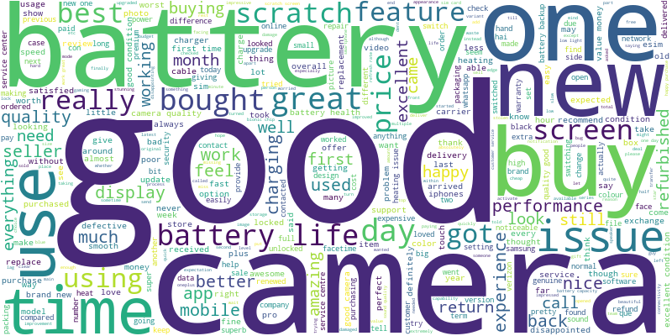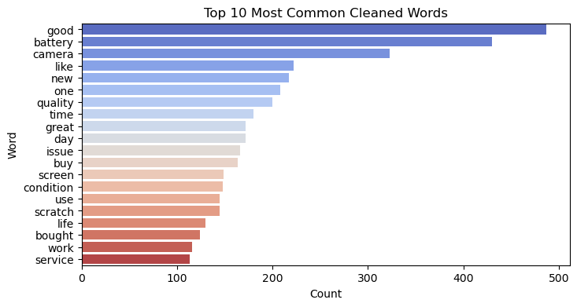
  - Figure 10: Overall Word Cloud and its frequency plot (author’s work)
However, from Figure 10, it is complicated to recognise which factors are advantageous and disadvantageous. Therefore, in Figure 11, the word cloud is separated into positive and negative word clouds, clearly indicating the product’s current strengths and weaknesses as expressed by customers. Although there are some similar words appearing in both the positive and negative word clouds, such as “camera” or “battery”, this does not necessarily contradict the analysis.
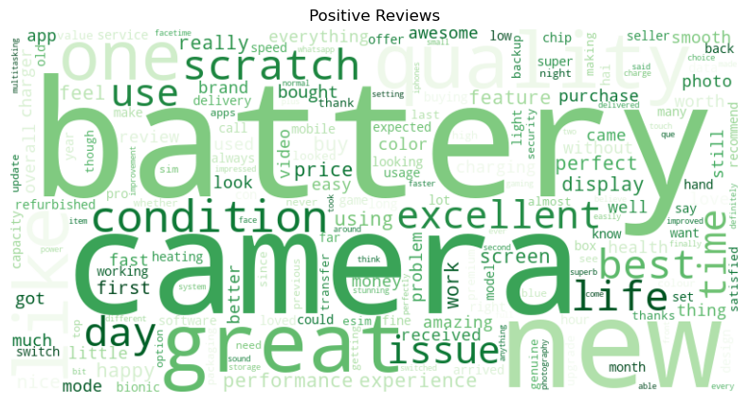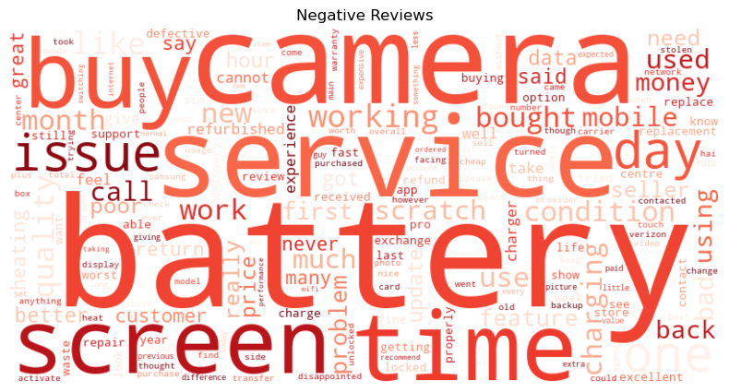
  - Figure 11: Positive reviews and Negative reviews Word Cloud (author’s work)
To resolve this ambiguity and provide a clearer interpretation, a frequency plot has been used to identify how often these key terms appear within each sentiment category (Figure 12). By comparing the exact frequencies, it becomes easier to determine whether a term is predominantly associated with positive or negative sentiment.
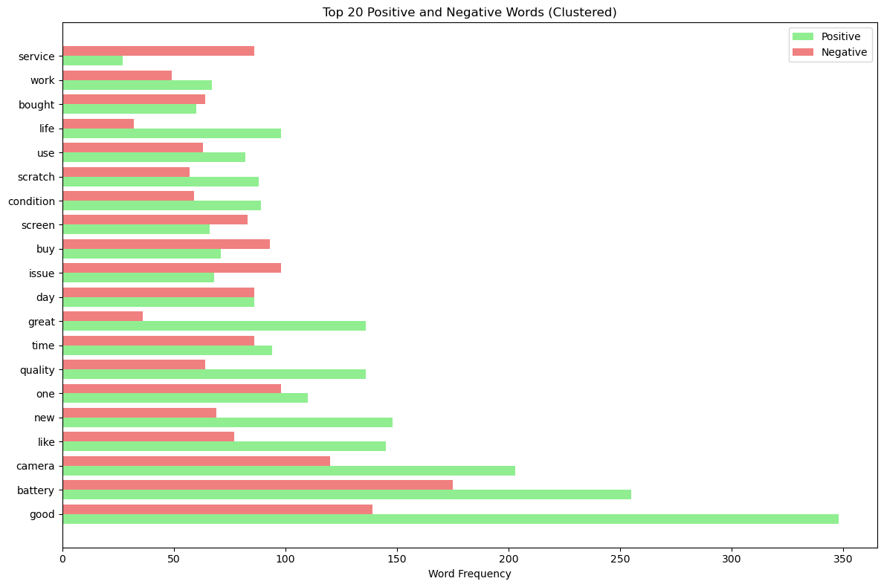
  - Figure 12: Frequency plot of positive and negative reviews (author’s work)
The visualisations include bigrams (Figure 13) and trigrams frequency plots (Figure 14). From results of figure 12, it highlights key components that may impact on iPhone purchases, such as the customers consider about the battery life, camera quality, the smartphone’s condition, etc. However, the results of figure 13 mostly show the common phrases relating to the customers satisfaction, such as the iPhone has Retina XDR display, good camera quality, and feel premium in hand and their expectations to improve, like looking for charging fast and battery. Besides that, there is also dissatisfied factor, such as the brand-new phone but having scratch.

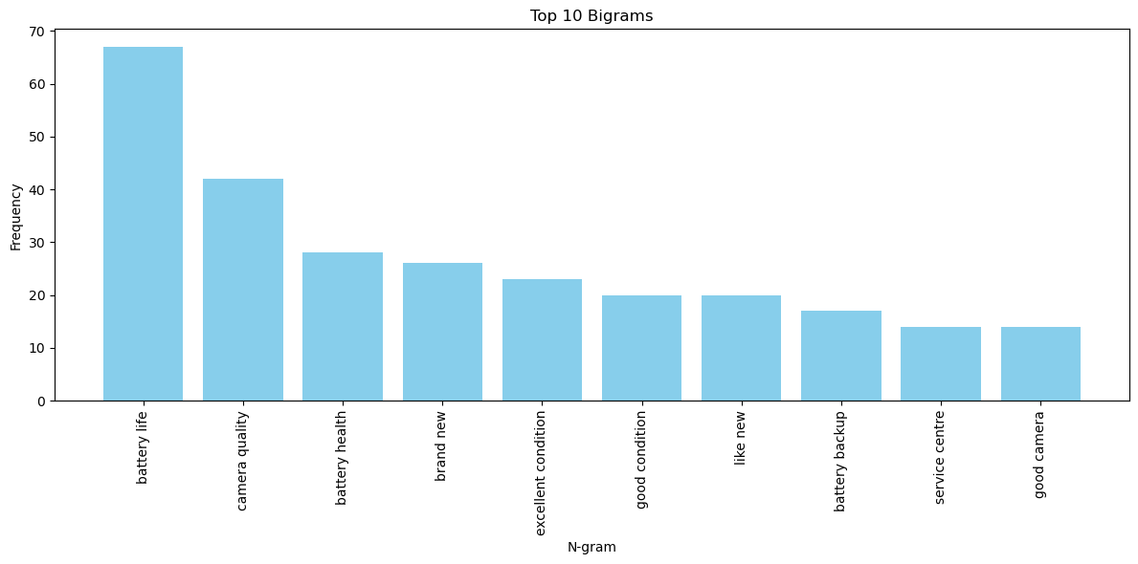
  - Figure 13: Frequency plot of Bigrams (author’s work)
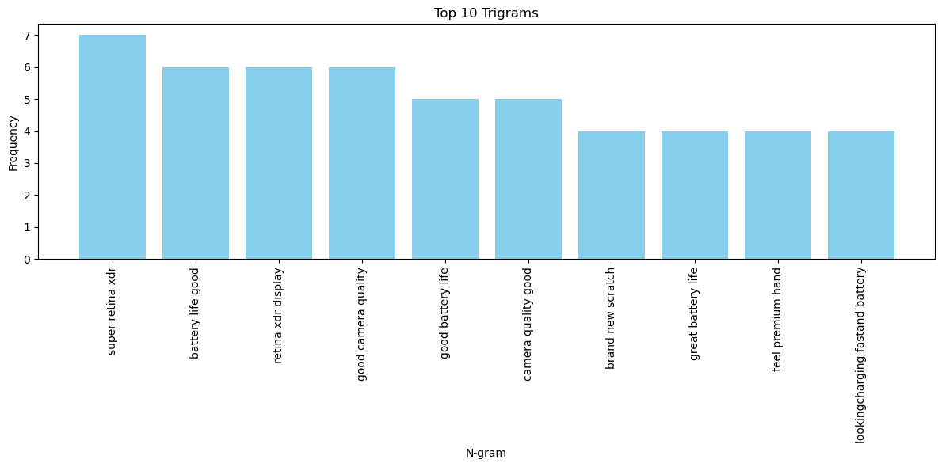
  - Figure 14: Frequency plot of Trigrams (author’s work)
Lastly, Figure 15 illustrates topic trends over time using LDA topic modeling. The graph shows that topics such as ‘Product Condition & Initial Quality’ and ‘Usability & Daily Functionality’ have gained prominence in 2024, suggesting rising consumer expectations and satisfaction in those areas. Monitoring these trends helps companies like Apple respond to evolving customer needs, offering real-time feedback loops for innovation and service improvement.
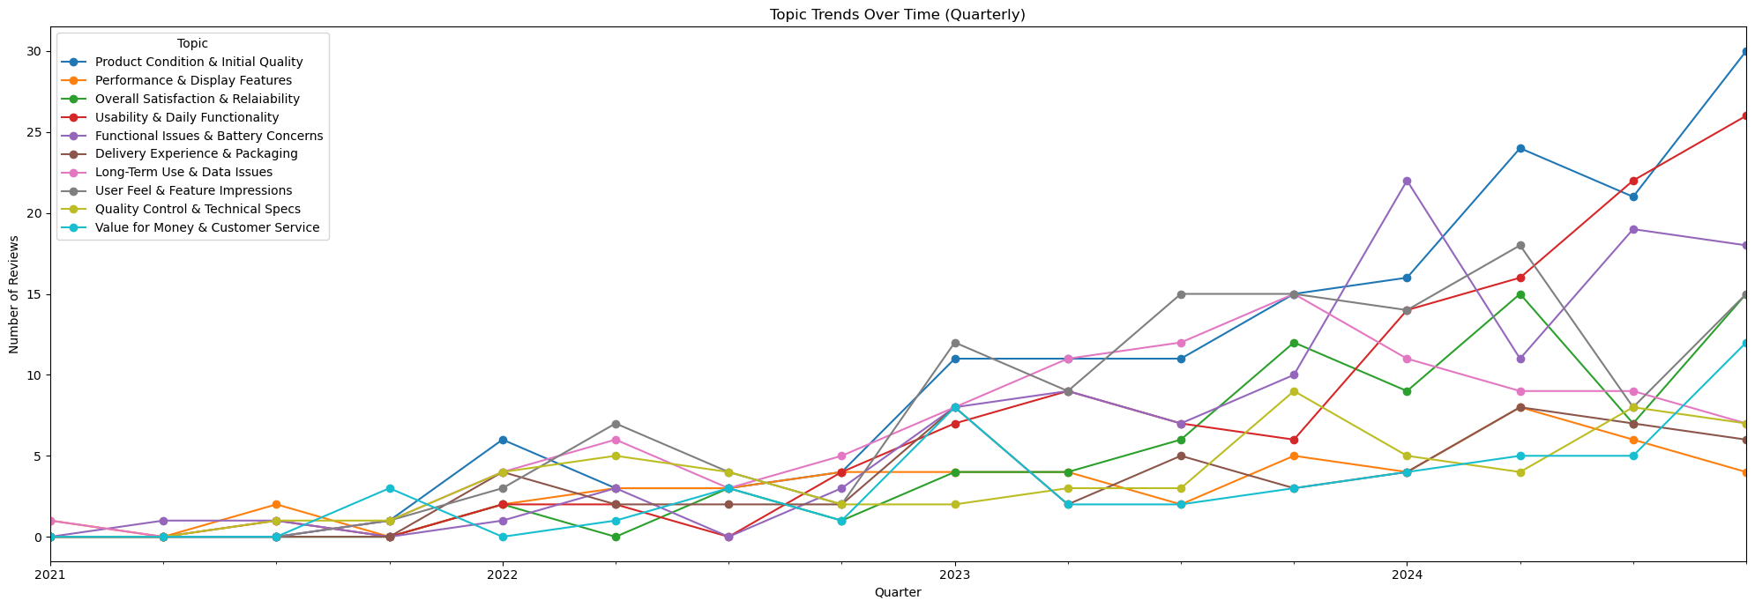
  - Figure 15: Top 10 topics modeling after LDA (author’s work)

Discussion and Conclusion

Ethical Considerations
The integration of NLP in analysing customer reviews offers significant opportunities for businesses like Apple to gain deeper insights into consumer sentiment and support strategic decision-making. However, this powerful technology also introduces important ethical considerations that must not be overlooked.
One of the foremost concerns is privacy and data consent. While platforms such as Amazon host public reviews, ethical use still requires careful handling of user-generated content. Even without collecting personally identifiable information, it's crucial to ensure compliance with data protection laws like the GDPR (Phillips, 2018). Maintaining transparency about how data is collected and used not only adheres to legal standards but also fosters trust among users (Floridi & Cowls, 2019).
Another concern is bias and fairness. NLP models can inherit or amplify biases present in the dataset. For example, if certain demographic groups are more active in leaving reviews, the model might disproportionately reflect their opinions, potentially leading to skewed or discriminatory insights (Blodgett et al., 2020). Mitigating this requires diverse data collection, regular audits, and robust labeling techniques. Lastly, the misuse of insights poses a risk. Businesses must avoid manipulating customers or exaggerating claims and instead use NLP to meaningfully improve products and experiences.

Conclusion
This report demonstrates the effective application of NLP to extract actionable insights from unstructured customer reviews, with a specific case study focused on Apple iPhone user feedback. In structured NLP pipeline, this project processed approximately 1000 customer reviews, like cleaning, tokenizing, lemmatizing, and vectorizing the data, to classify sentiments and identify underlying themes through topic modeling. Visualizations such as word clouds, frequency plots, and bigram/trigram charts enabled a clearer interpretation of customer concerns, preferences, and recurring issues. The application of LDA further revealed 10 common topics that reflected both strengths and areas for improvement in Apple’s product performance. Therefore, the approach integrated statistical and visual methods to make findings accessible and actionable for business stakeholders. Insights from sentiment analysis and topic modeling can inform decisions in marketing, product design, and customer service.
Nevertheless, ethical considerations remain crucial. From ensuring data privacy to addressing bias and potential misuse of insights, highlighting the responsibility of organisations when applying AI. It not only protects user rights but also strengthens trust in digital systems and maintains the integrity of business practices. In this context, NLP serves as a transformative tool in the digital strategy of customer-centric businesses, aligning products with user expectations, resolve dissatisfaction proactively, and foster innovation.

References
Blodgett, S. L., Barocas, S., Daumé III, H., & Wallach, H. (2020). Language (Technology) is Power: A Critical Survey of “Bias” in NLP. Proceedings of the 58th Annual Meeting of the Association for Computational Linguistics. https://doi.org/10.18653/v1/2020.acl-main.485
Cambria, E., & White, B. (2014). Jumping NLP Curves: A Review of Natural Language Processing Research. IEEE Computational Intelligence Magazine, 9(2), 48–57. https://doi.org/10.1109/MCI.2014.2307227
Chauhan, U., & Shah, A. (2022). Topic Modeling Using Latent Dirichlet allocation: A Survey. ACM Computing Surveys, 54(7), 1–35. https://doi.org/10.1145/3462478
Eskandar, S. (2023, April 12). Challenges and Solutions for Text Mining. Performing Sentiment Analysis and Topic Modeling. Medium. https://medium.com/@eskandar.sahel/challenges-and-solutions-for-text-mining-performing-sentiment-analysis-and-topic-modeling-b53a1cd9e484
Fanni, S. C., Febi, M., Aghakhanyan, G., & Neri, E. (2023). Natural language processing. In Introduction to artificial intelligence (pp. 87-99). Cham: Springer International Publishing.
Feldman, R., & Sanger, J. (2007). Advanced Approaches in Analyzing Unstructured Data. The Text Mining Handbook, Cambrige University.
Floridi, L., & Cowls, J. (2019). A Unified Framework of Five Principles for AI in Society. Harvard Data Science Review, 1(1). https://doi.org/10.1162/99608f92.8cd550d1
Heimerl, F., Lohmann, S., Lange, S., & Ertl, T. (2014). Word Cloud Explorer: Text Analytics Based on Word Clouds. 2014 47th Hawaii International Conference on System Sciences, 1833–1842. https://doi.org/10.1109/HICSS.2014.231
Lauriola, I., Lavelli, A., & Aiolli, F. (2022a). An introduction to deep learning in natural language processing: Models, techniques, and tools. Neurocomputing, 470, 443-456. https://doi.org/10.1016/j.neucom.2021.05.103
Lauriola, I., Lavelli, A., & Aiolli, F. (2022b). An introduction to deep learning in natural language processing: Models, techniques, and tools. Neurocomputing, 470, 443-456. https://doi.org/10.1016/j.neucom.2021.05.103
Lauriola, I., Lavelli, A., & Aiolli, F. (2022c). An introduction to deep learning in natural language processing: Models, techniques, and tools. Neurocomputing, 470, 443-456. https://doi.org/10.1016/j.neucom.2021.05.103
Müller, V. C. (2020). Ethics of artificial intelligence and robotics. https://plato.stanford.edu/entrieS/ethics-ai/
Phillips, M. (2018). International data-sharing norms: from the OECD to the General Data Protection Regulation (GDPR). Human Genetics., 137(8), 575–582. https://doi.org/10.1007/s00439-018-1919-7
Sinkovics, R. R., Penz, E., & Ghauri, P. N. (2005). Analysing textual data in international marketing research. Qualitative Market Research: an international journal, 8(1), 9-38.
Tan, C. M., Wang, Y. F., & Lee, C. D. (2002). The use of bigrams to enhance text categorization. Information processing & management, 38(4), 529-546. https://doi.org/10.1016/S0306-4573(01)00045-0
Uysal, A. K., & Gunal, S. (2014). The impact of preprocessing on text classification. Information processing & management, 50(1), 104-112. https://doi.org/10.1016/j.ipm.2013.08.006
Vinodhini, G., & Chandrasekaran, R. M. (2012). Sentiment analysis and opinion mining: a survey. International Journal, 2(6), 282-292. https://www.researchgate.net/profile/Vinodhini-G-2/publication/265163299_Sentiment_Analysis_and_Opinion_Mining_A_Survey/links/54018f330cf2bba34c1af133/Sentiment-Analysis-and-Opinion-Mining-A-Survey.pdf

